Is it important? |  |  |  | Yes Write it
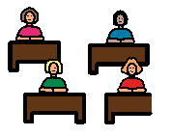Is it what everyone else is talking about? |  |  |  | Yes Hand up
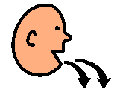Have I already said it? |  |  |  | Yes Forget it
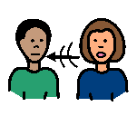Is the person talking to someone else? |  |  |  | Yes Hand up
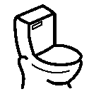Do I need something? |  |  |  | Yes Hand up
If calls out he will get a cross.
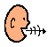
If calls out 5 times he won’t get a tick.

